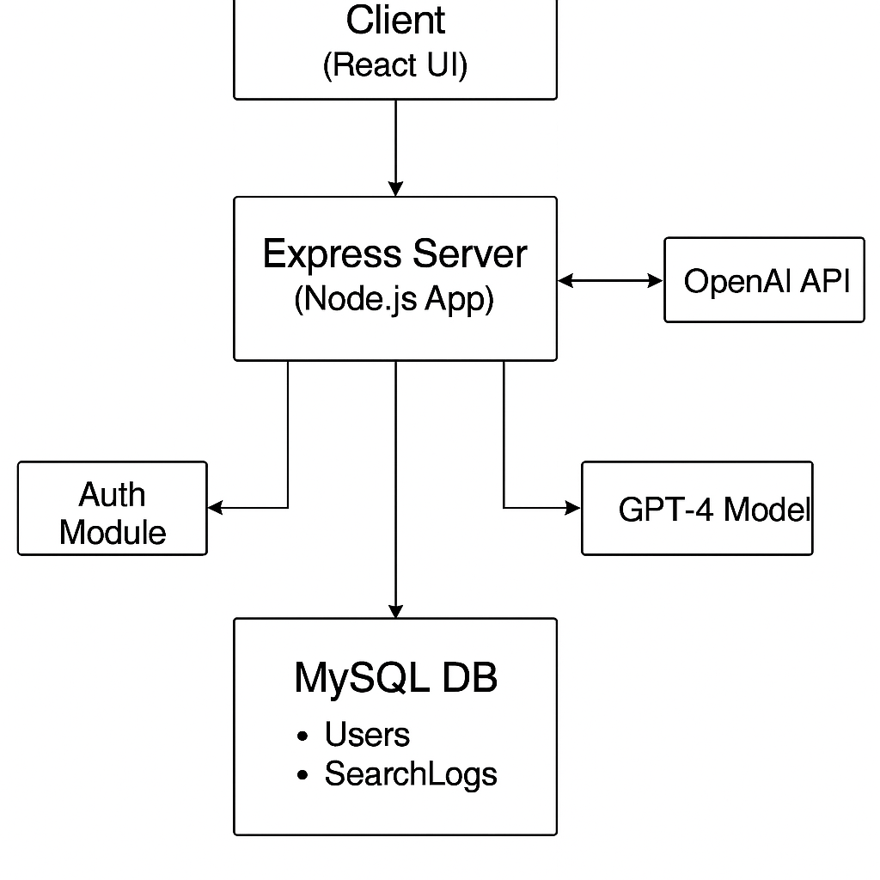

**Sequence Diagrams**

1. User Login and Logout

Client -> Server: Submit username and password

Server -> DB: Query user with hashed password

DB -> Server: Return user data (or none)

Server -> Client:

* If match: “Login successful”
* Else: “Invalid credentials”

Client -> Server: Logout request (optional if stateless)

1. User Previous Search History

Client -> Server: Request past search history

Server -> DB: SELECT * FROM search_history WHERE username = ?

DB -> Server: Return previous queries

Server -> Client: Display query history

1. Search Feature

Client -> Server: Send search query

Server -> OpenAI: Submit formatted prompt

OpenAI -> Server: Return law data (title, desc, link, citation)

Server -> DB: Log search for user

Server -> Client: Return results

1. Citation Feature

Client -> Server: Request laws with citation

Server -> OpenAI: Prompt includes “return citation in MLA format”

OpenAI -> Server: Returns JSON with citation field

Server -> Client: Display citation

1. Direct Link to Website Feature

Client -> Server: Search laws

Server -> OpenAI: Prompt includes “return source link”

OpenAI -> Server: Returns JSON with url field

Server -> Client: Render clickable link